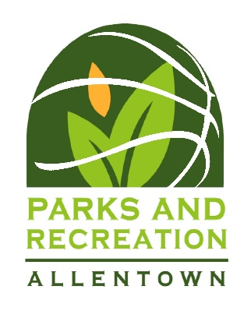
Sportsmanship Announcement
The City of Allentown Recreation Department would like to remind everyone that we are enforcing sportsmanship rules for coaches, players, and spectators. Everyone is expected to conduct themselves in a respectful manner during today’s game. Disrespectful words or actions will not be tolerated. We reserve the right to remove any individual whose behavior is deemed harmful to our programs. Let today’s game reflect mutual respect, while giving our kids a safe positive place to compete while having fun.
Good Luck to All Participants!

****BE SURE TO READ TO COACHES AND PLAYERS PRIOR TO START OF GAME!!!****

