Allentown Hometown Heroes Banners (2024 & 2025)
The Allentown Hometown Heroes Banner Program is a living tribute created for the community to recognize and honor our Allentown Veterans who are serving or are veterans who have served our country in the United States Armed Forces.
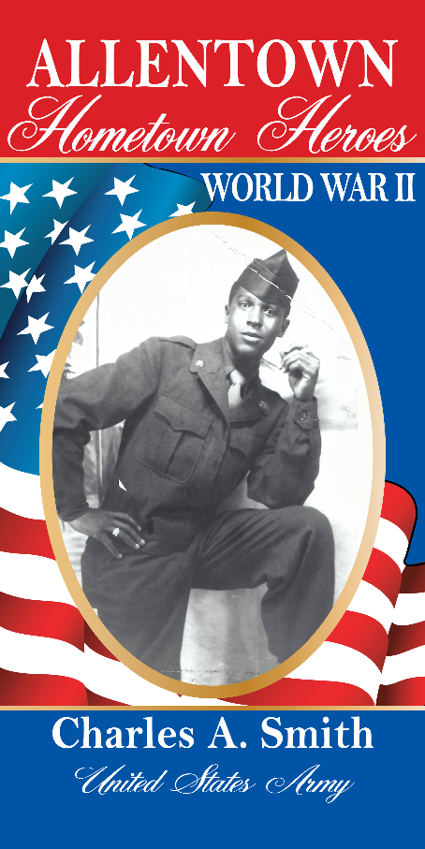
To qualify, a Veteran, living or deceased, must have had a connection to Allentown (attended local schools, relative, friend, etc.) at some point in his or her life, also those honored on Allentown War Memorials and Veterans recommended by the local VFW and American Legion Posts.

The Banner will be 30” x 60” 18 oz., heavy vinyl, printed the same on both sides, and will display the service person’s photograph, include their full name, branch of the Military and the era of service (WWI, WWII, Vietnam, etc.) Banners will be displayed in years 2024 & 2025 from May through Veterans Day in November in observance of all Military Branch birthdays. Banners will be removed and stored until the same period in the following year at which time they will be redisplayed.

Each Banner requires the Hometown Hero Form to be filled out, a photograph of the Hero in uniform and a payment of $150.00 for each banner, payable to: Hometown Heroes. Please Mail to Anne.
For further information please contact Anne Henning Scheuring, 225 South Line Street, Lansdale, PA. 19446 or at E-Mail address: heroes@verizon.net or call: (215) 855-1743

